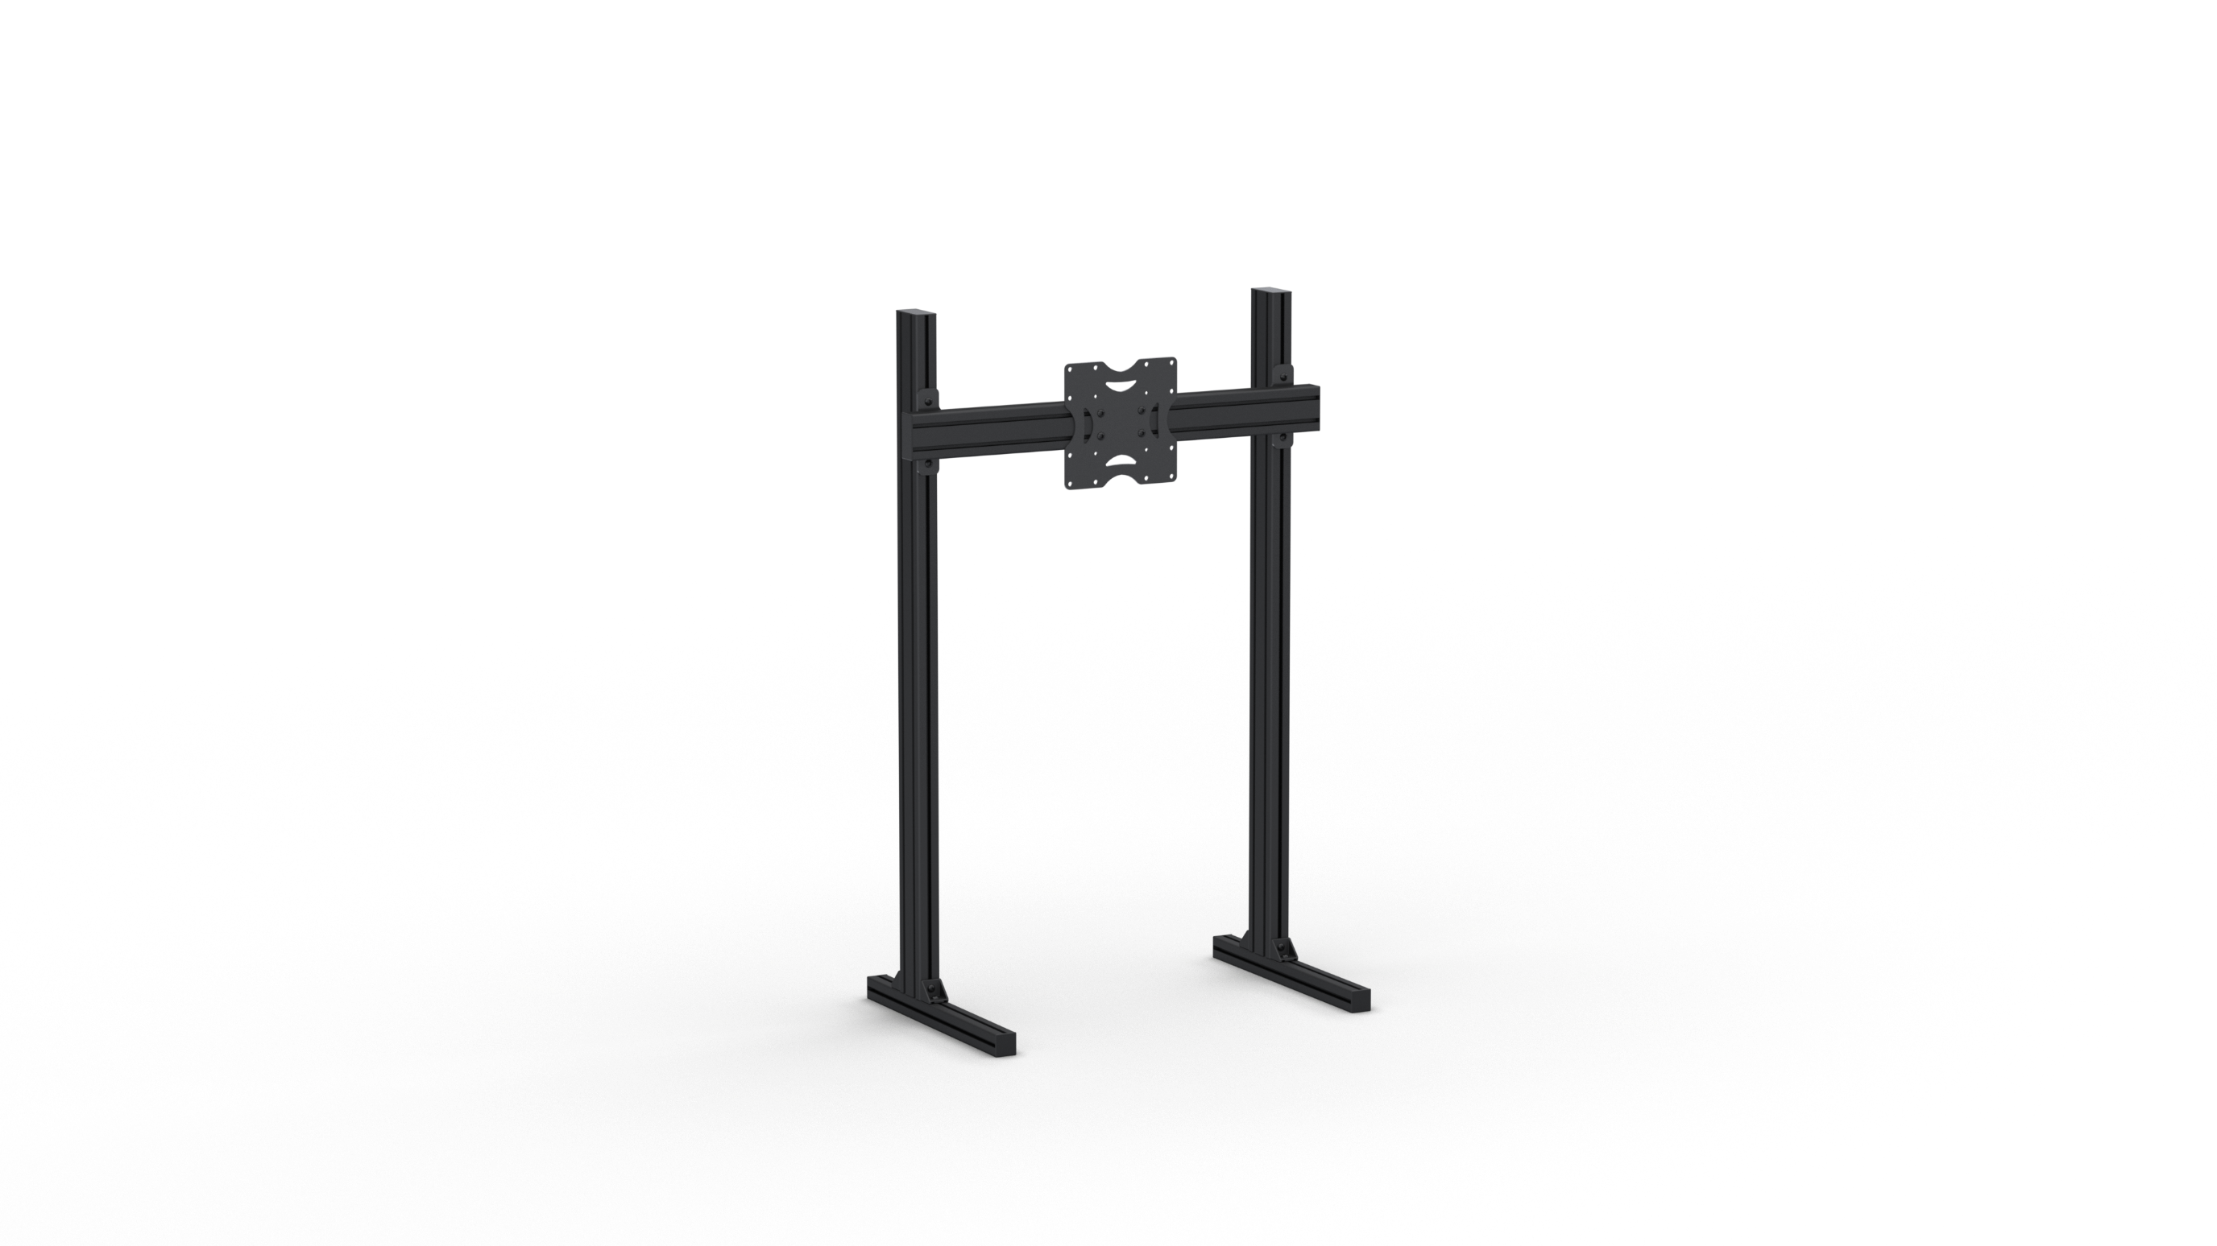INSTRUCTION MANUAL



**sim-pole.com**

Copyright © 2022 – Sim-pole Products | revision 1.0

# Part list

## Parts

|  |  |  |
| --- | --- | --- |
| Item nr. | Description | Qty |
| A | Profile 4040 500mm | 2 |
| B | Profile 4080 1200mm | 2 |
| C | Upper plate | 2 |
| D | Profile 4080 800mm | 1 |
| E | TV bracket | 1 |

## Fasteners

|  |  |  |
| --- | --- | --- |
| Item nr. | Description | Qty |
| 1 | M8x20 bolt | 18 |
| 2 | M8 t-slot nut | 18 |
| 3 | Corner bracket 4040 | 4 |
| 4 | End cap 4040 | 4 |
| 5 | End cap 4080 | 4 |

# Tools required

# 

6mm

# Step 1

2x

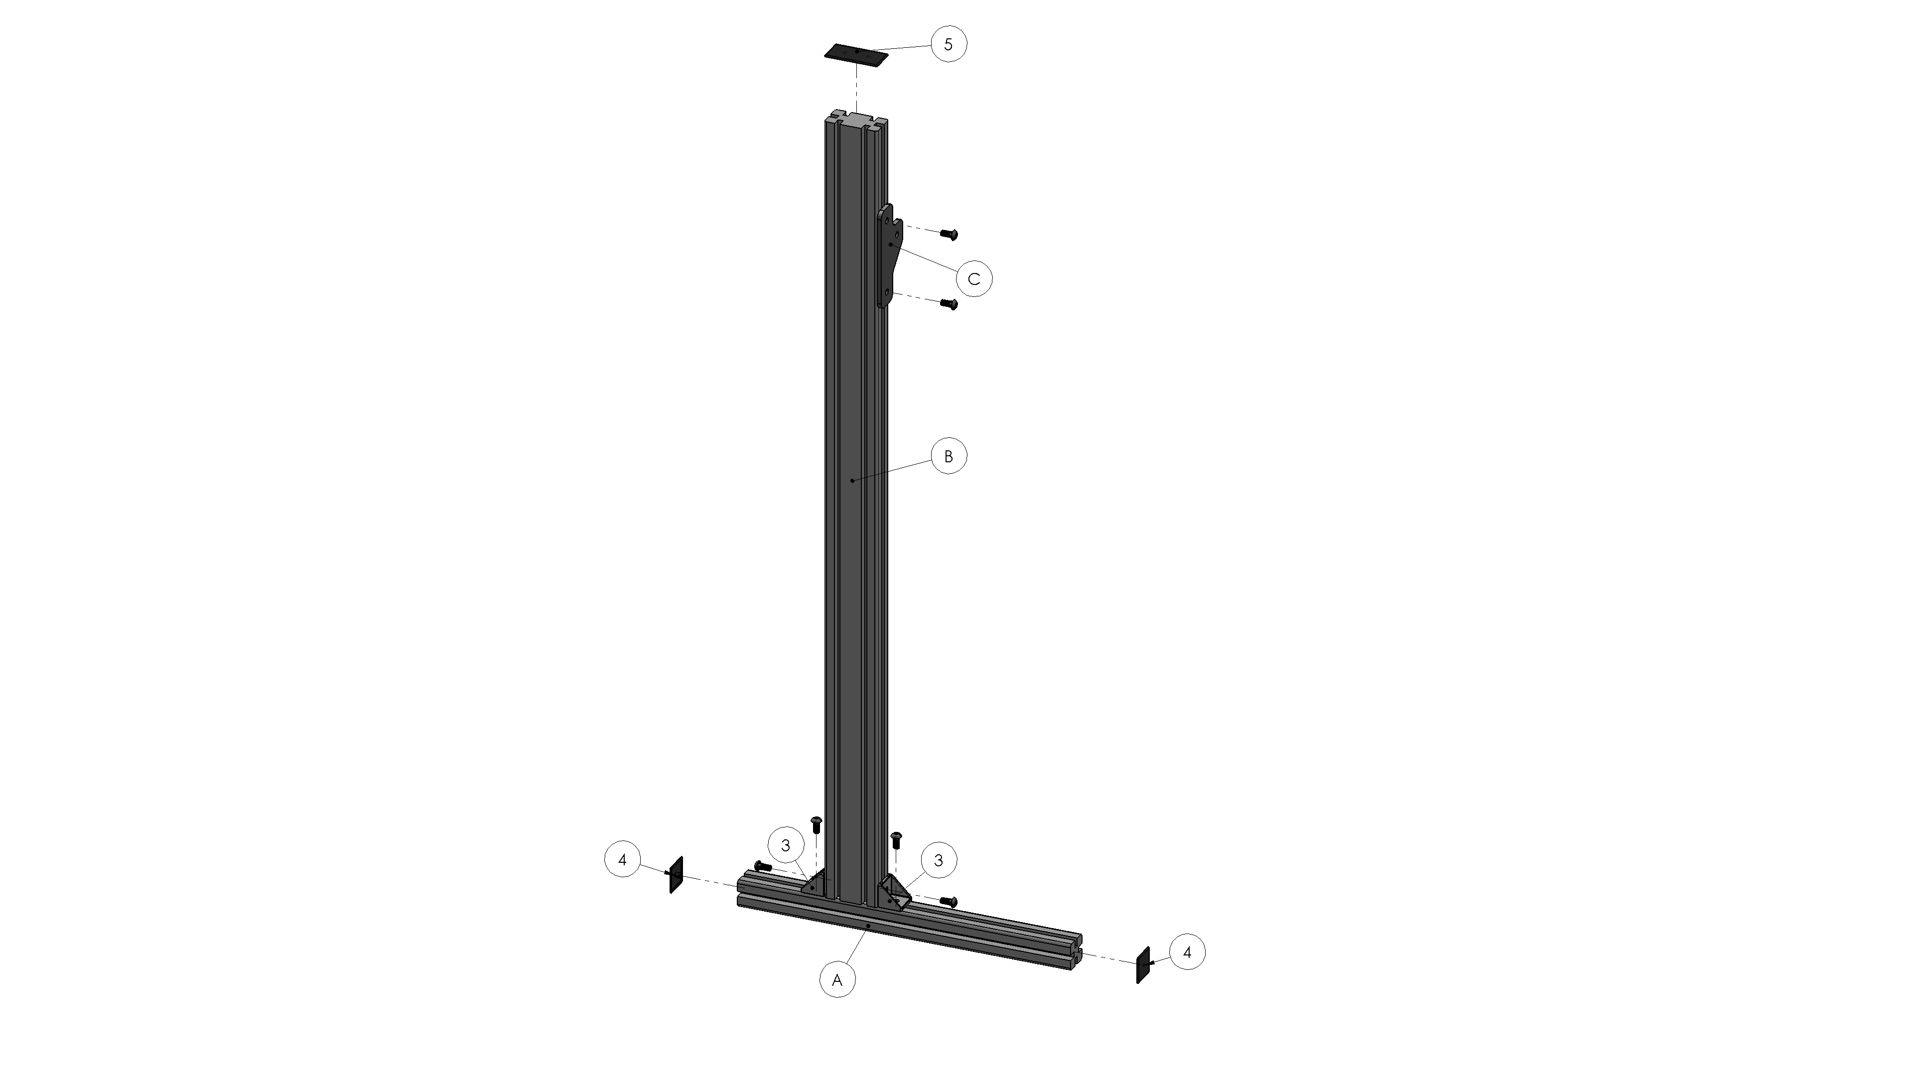

|  |  |  |
| --- | --- | --- |
| Item nr. | Description | Qty |
| A | Profile 4040 500mm | 2 |
| B | Profile 4080 1200mm | 2 |
| C | Upper plate | 2 |
| 1 | M8x20 bolt | 12 |
| 2 | M8 t-slot nut | 12 |
| 3 | Corner bracket 4040 | 4 |
| 4 | End cap 4040 | 4 |
| 5 | End cap 4080 | 2 |

# Step 2



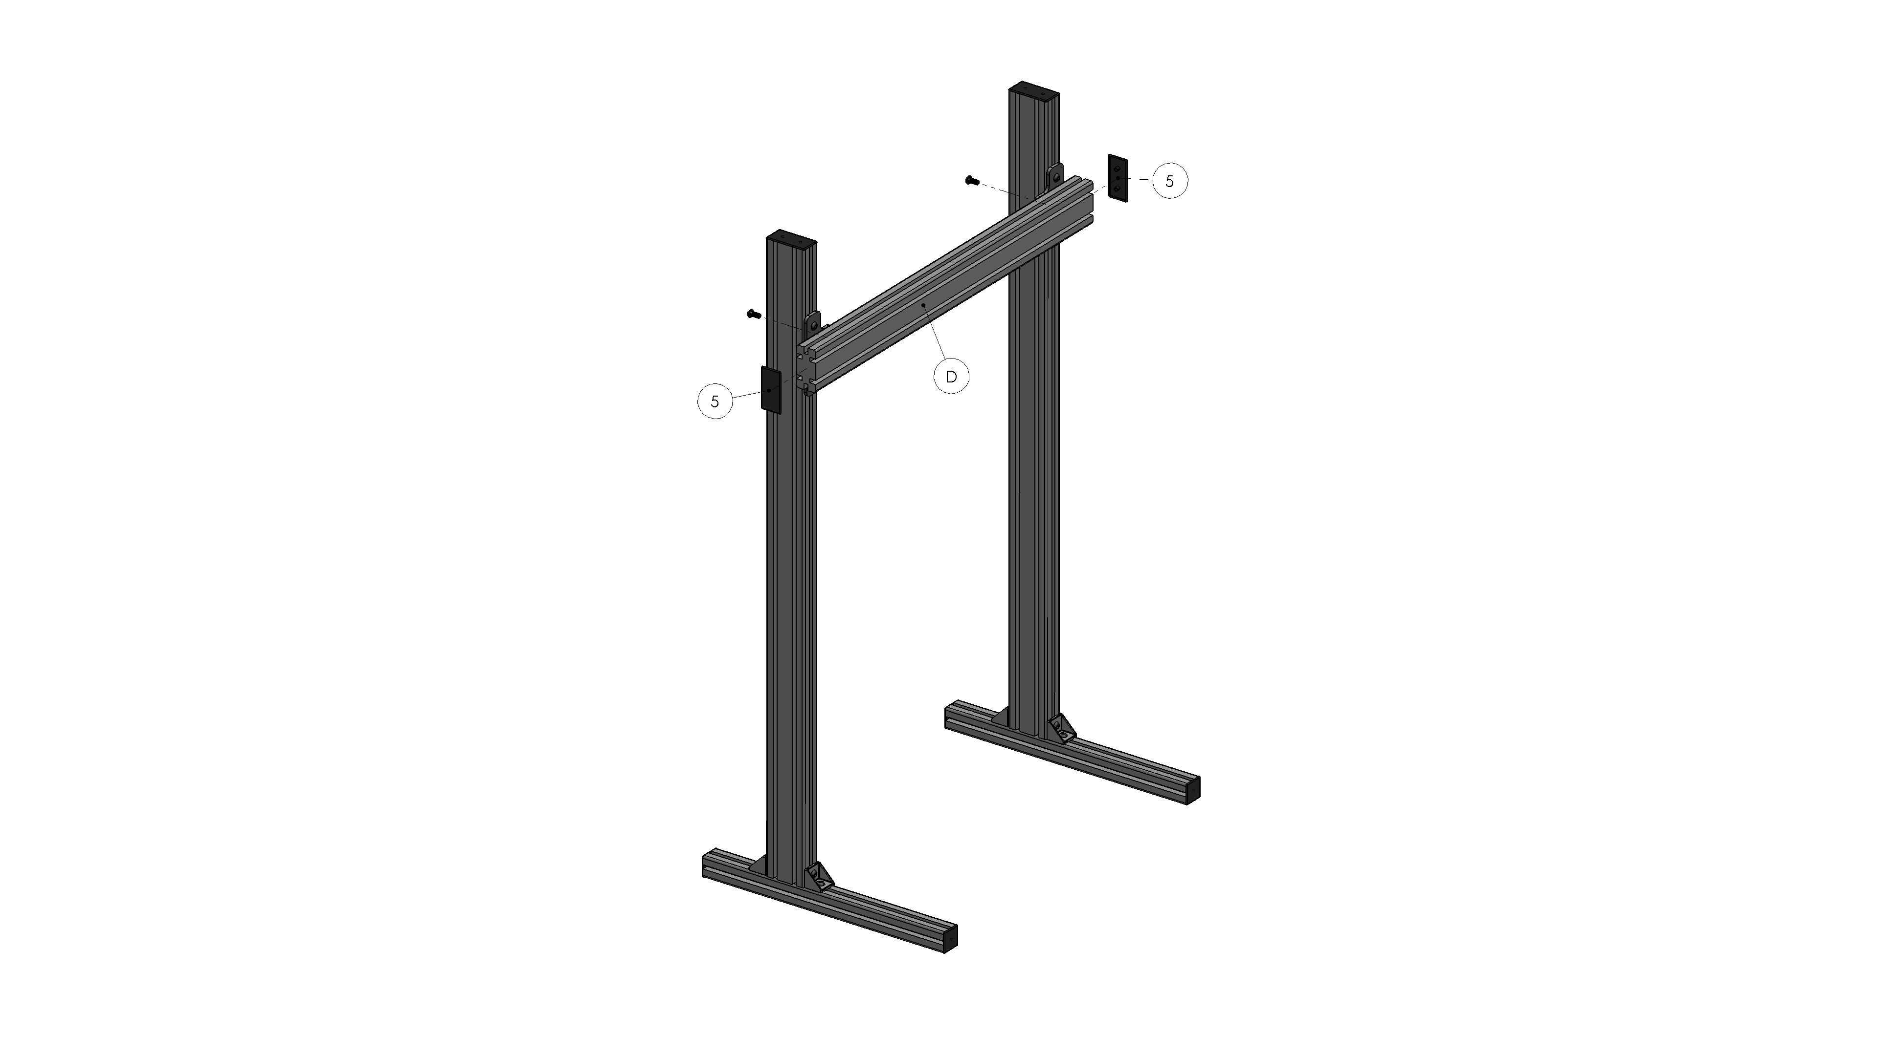

|  |  |  |
| --- | --- | --- |
| Item nr. | Description | Qty |
| D | Profile 4080 800mm | 1 |
| 1 | M8x20 bolt | 2 |
| 2 | M8 t-slot nut | 2 |
| 5 | End cap 4080 | 2 |

# Step 3

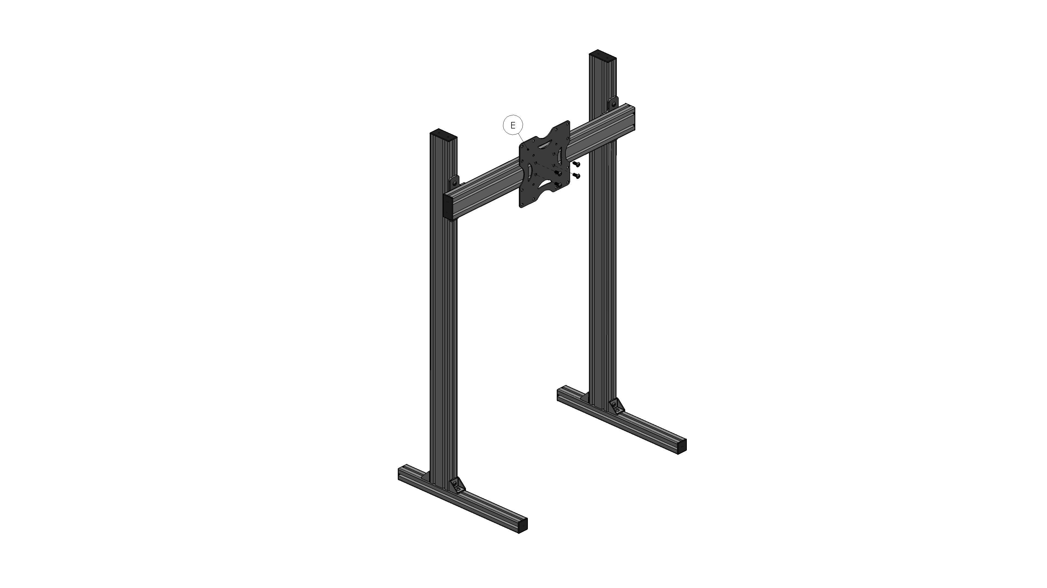



|  |  |  |
| --- | --- | --- |
| Item nr. | Description | Qty |
| E | TV bracket | 1 |
| 1 | M8x20 bolt | 4 |
| 2 | M8 t-slot nut | 4 |